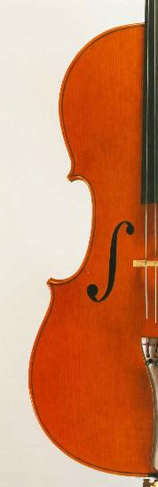
Return to the Baltic
Grieg
Peer Gynt Suite No.1

Miaskovsky
Cello Concerto
Soloist: Julian Metzger

Tchaikovsky
Symphony No.6 ‘Pathetique’

Conductor: David Knight

Saturday 20th November 2010
7:45pm
Church of Christ the Cornerstone
Central Milton Keynes

Tickets: £12, Concessions £10,
Under 16’s £3
Please telephone:
01908 377518

