
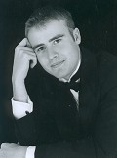
Mozart
Serenade for 13 wind instruments
in B flat major, K361/370a

Beethoven
Piano Concerto No.4 in G major, Op.58
Soloist – Tim Short

Vaughan-Williams
Fantasia on a Theme by Thomas Tallis

Stravinsky
Suite from The Firebird (1919)

Conductor – David Knight
Saturday 3rd December 2011
7:45pm
Church of Christ the Cornerstone
Central Milton Keynes

Tickets: £12, Concessions £10, Under 16’s £3
Please telephone:
(01908) 377518
40th Anniversary Concert
Tim Short

